Climate and energy
Sustainability Report 2026 – Chapter 2 (draft)
Hannah Weber · 29 September 2026
Draft v2 · figures Jan–Aug 2026 [YTD] · owner Hannah Weber / Clara Neumann · reviewer Marcus Bell

Our approach
Climate change mitigation is our most material topic and the reason Weyland exists. We report emissions under the GHG Protocol (operational control) and the avoided emissions of our generation separately.

Avoided emissions
Our operating portfolio of 1,100 MW generated around 2.2 TWh in 2025 and avoided an estimated 1.2 Mt of CO₂ compared with the grid operating margin in Germany, the UK and Denmark.

Our own footprint (GRI 305-1, 305-2, 305-3)
tCO2e | 2025 | 2026 YTD | Comment
Scope 1 | ≈ 500 | ≈ 270 | Company cars, generators, SF6
Scope 2 (market-based) | 118 | 75 | Copenhagen office still on grey tariff
Scope 3 | ≈ 54,400 | ≈ 117,500 | Harrow Bay foundations and substation, vessels

Scope 3 more than doubles in 2026 because of the Harrow Bay construction: steel for monopiles and transition pieces, the substation and fuel for the MV Sea Atlas. Per MWh of lifetime generation, Harrow Bay's construction footprint is estimated at 9–11 gCO2e – far below any fossil alternative.

Targets
- Scope 1 and 2: −90 % by 2030 vs. 2023 (fleet electrification, 100 % renewable electricity)
- Scope 3: supplier engagement – EPDs from all major suppliers by 2027
- Low-carbon steel: at least 30 % of foundation steel for the next offshore project
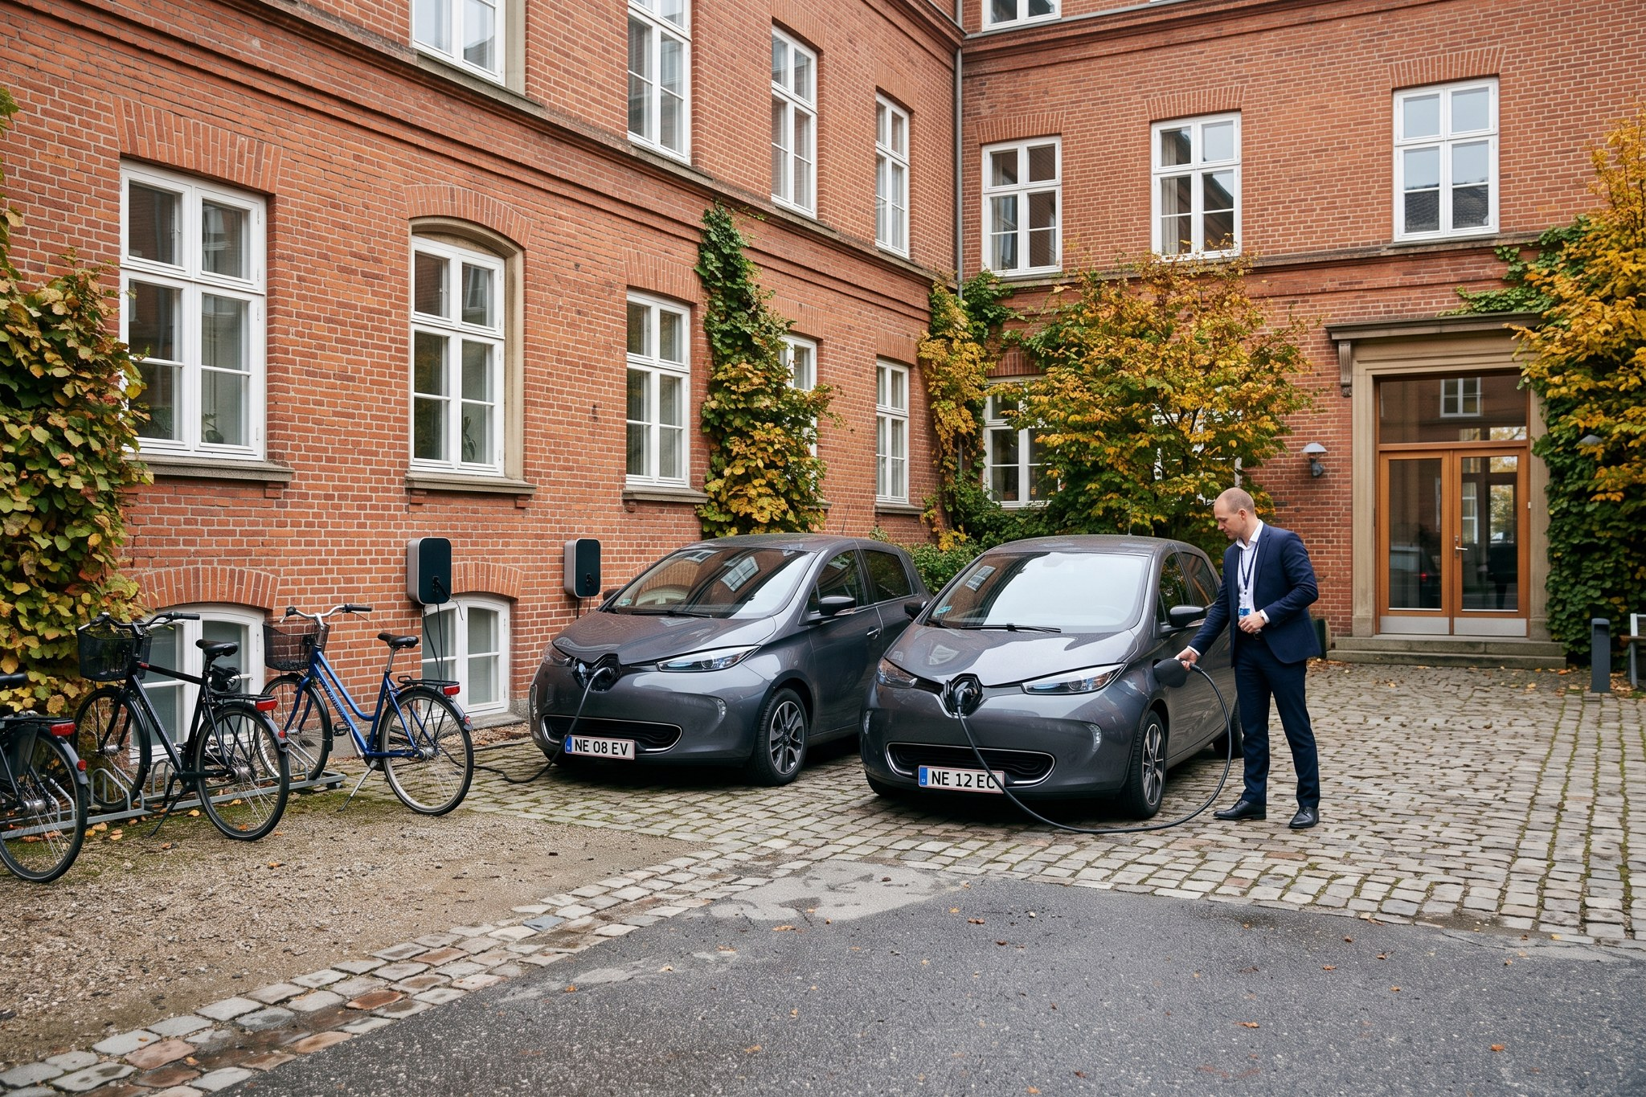
Electric pool cars at the Hamburg office.

